We have been exploring alternate classroom space within our local community to support our instructional needs for the upcoming school year. There is an opportunity to lease 1616 Jordan Drive in Saxapahaw (formerly The Culture Mill), which could enhance our learning environment and support our students' growth.

Below is an overview of the space's location, its intended use, and the safety procedures that would be in place for students.

This space would be used only for instructional purposes and would primarily support our 9-12 students/teachers. I have discussed with our Economics and Personal Finance/Outdoor Leadership the possibility of moving into this space.

Proposed Space:

- Location: 1616 Jordan Drive, Saxapahaw
- Former Tenant: The Culture Mill
- Size: 2,633 square feet
- Monthly Rent: $1,450 (Commercial Lease)

(Before leasing, the school would be responsible for paying the outstanding balance associated with the previous sprinkler leak)

Student Safety Procedures:

Student safety is our highest priority. The following procedures will be in place to ensure students are protected and supervised at all times:

- Students will not travel on Saxapahaw-Bethlehem Church Road or any highway.
- Students will walk using the existing trail that Hawbridge students already use when attending activities at the Haywagon Stage. The route follows the pathway near the Mill Houses directly to 1616 Jordan Drive.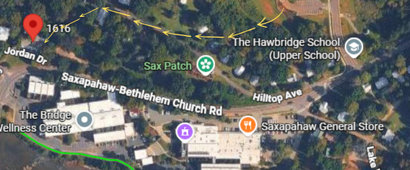
- Students will sign out through the Front Office before leaving campus and sign back in upon returning.
- Students will travel only to the approved instructional location.

Participation in off-campus instruction will require a signed parent permission form; all students will be held to the same attendance expectation outlined in our Student-Parent Handbook. Students may travel only to approved destinations and must follow the Student Code of Conduct.

Last year, we used this system for our peer mentoring program between upper- and lower-school students, Hawbuddies.

We invite your support for this opportunity to cost-effectively address our need for additional instructional space and to enhance place-based learning while ensuring student safety.

